**Tourism Management System**

# Abstract

Access to relevant and accurate information is at the heart of tourism, more so in this era of the Internet information overload has become a prevalent phenomenon and as such a serious issue for those seeking for appropriate information. Furthermore, various researches have been carried out on how to make information on tourism website more effective. Tourism Management System tries to bridge the gap by noting what a tourist perceives as relevant, in terms of content pertaining to tourism products in tourism websites. This study focuses mainly on content because it is seen as the key factor associated with an effective website. Hence, the aim of this research entails the design and implementation of an intelligent platform that will assist tourists in gaining access to information on tourist locations in Nigeria. In view of the forgoing, the system was implemented using Rational Unified Process as the adopted software development process, whereas MySQL, HTML and PHP were the implementation tools used in the development of the system. Upon completion, the system was able to provide information by fetching information from the web pertaining to the subject of interest to assist tourists in decision making process. It was also able to act intelligently by using hybrid recommendation technique to recommend tourist locations based on their preference.

# Introduction

Over the years, tourism has continued to gain massive interest at a global scale. It is a major foreign exchange earner for a good number of advanced and emerging economies. It is also true that information explosion makes it cumbersome times to access relevant information to enhance decision making. This has given rise to the emergence of intelligent systems or mechanisms that facilitate quick access to relevant content found in the Internet [1,2]. For developing countries like Nigeria, tourism is one of the untapped but potentially big income generator. There are about 142 tourist destinations that spread across the 36 states of the federal republic of Nigeria. Whereas some exist naturally, others are manmade [3].

In this era that has witnessed rapid advances in information technology, information overload has become a serious problem to those seeking for information online. Recently, intelligent search mechanisms have been deployed on the web that shows that the problem of information overload can be partially eliminated by providing a platform with more intelligence to assist tourists in the search for relevant information [4]. Google.com is an example of an intelligent search engine that helps users with information and another class of intelligent system that has proven relevant in addressing the problem of information overload are recommender systems [5].

In the aspect of tourism, Internet and web technologies have made more readily available information on tourist locations, accommodations, transportation, shopping, food, festivals, and other attractions, thus improving tourism experience [6].

The goal of this research is to design and implement intelligent platform that will aid tourists in Nigeria to have access to information on tourist locations thus help fasten their decision making process.

# Review of Closely Related Works

So many researches have been carried out relating to intelligent tourism management systems with significant impact in the tourism industry around the globe. Some of the research works carried out by researchers as related to Tourism Management Systemare discussed in the succeeding sub-sections.

## The Application of Intelligent Tourism Mobile Client Based On Ontology

This paper proposed the application of ontology theory in the research of intelligent tourism mobile application client. The adopted method (ontology) helps to structure the kind of information given to tourists thus eliminating room for information ambiguity. The strength of this research work is based on the fact that it makes use of an organic combination of the major elements that are closely linked to tourism, and infiltrates them it into every aspect of tourism which produces an effective, intelligent and efficient tourism information system. However, its weakness is based on the fact that it is mobile-based and hence accessibility is limited to mobile device users [7].

## Destination Information Management System for Tourists

The system was designed for tourists taking Nigeria’s tourism into consideration. This was to provide tourists with intelligent interaction based on virtual community concept of tourism and locals that have common interest theme. The system aims at bridging the gap; which is the lack of interaction that exists between tourists and locals at a particular destination. The system was designed using Java Applet (Netbeans IDE 6.1), HTML, PHP and Java script whereas MySQL was used to design the database. The advantages of the system is it is user- friendly, interactive, supports security and compatible to various web servers but the system lacks intelligence in providing information to tourists, thus reducing the stress at which tourists seek for information on the system [1].

# Methodology

The approach employed in designing the proposed system is the Rational Unified Process (RUP)**.** The RUP methodology is based on the fact that the system represents an organized way of gathering business requirements and building the goal of the project. This was employed, because it is an object-oriented and web- enabled program development methodology and also a framework for developing software systems. It also clearly outlines the different roles of the individuals involved in the project, such as the project manager, business analyst and developers. Some characteristics of Rational Unified Process include;

1. **Developing iteratively:** This involves developing software in repeated cycles. With each cycle, additional features are designed and developed in the system until the system is fully functional and ready for deployment to the customer.
2. **Managing requirements:** This involves explicit documentation of the user’s requirement and keeping track of changes with respect to the requirement. It also analyses the system and the impact those changes will make on the system before taking them into consideration.
3. **Using component-based architectures**: This involves structuring the system architecture into components.
4. **Modelling software visually:** Using graphical UML to present the software’s dynamic and static view
5. **Quality verification:** It ensures that software meets the organizational quality standards
6. **Control over changes:** it gives room for changes in the software to be managed efficiently using a change management system and configuration management procedures and tools [8].

## Entity Relationship Diagram

Entity relationship diagram as depicted in Figure 1, is a graphical representation of entities and their relationships with each other. It is also refers to as the organization of data within the database or system on the logical representation of the database on Tourism Management System(TMS).

## Hardware And Software Requirement

For the software to be able to run efficiently on computers, it needs certain hardware components or some software to be present. The software requirements are:

* + 1. Operating System (32 or 64bit Windows 7/vista/XP and latter , Linux, mac OS, android OS)
    2. Processor (1 dual core or single core processor)
    3. Internet browser (Mozilla Firefox (most suitable), opera mini, Google chrome, or internet explorer)
    4. Xampp

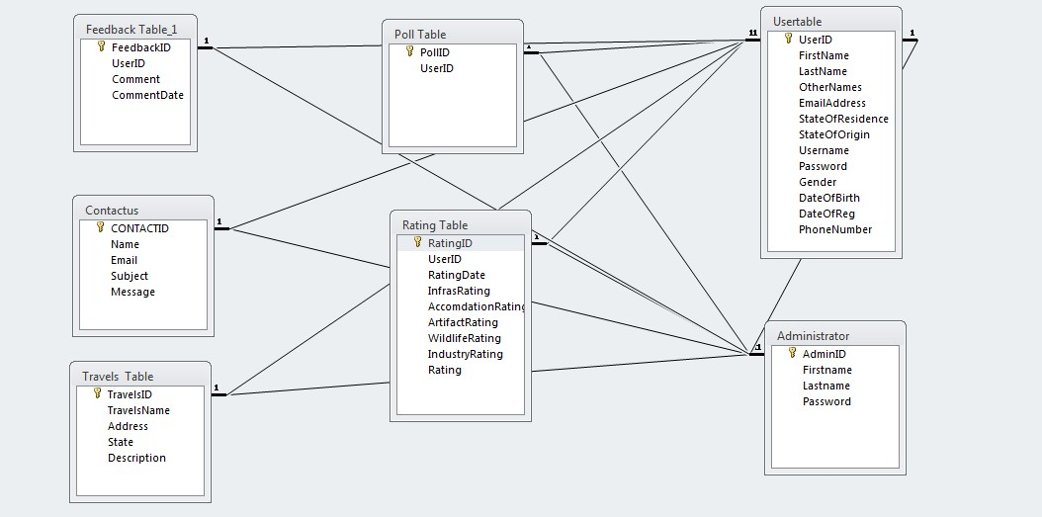

**Figure 1:** Entity Relationship Diagram for TMS The hardware requirements are:

1. CPU (Pentium III, 950MHz, CPU)
2. Memory (256MB RAM)
3. Video graphics adaptor (16bit VGA)
4. Network card (1GB Ethernet)
5. Hard disk (5GB)

## Sequence Diagram

A sequence diagram shows the interaction of how processes operate with one another and in what order they operate. It illustrates how messages are sent and received between objects. A system sequence diagram as captured in Figure 2, depicts the following;

1. The actor of the use case
2. The messages from the actor to the system
3. The order in which the messages occur
4. The external system that sends the message to system and
5. The system itself (in a block format) [9].

In addition, Figure 2 which captures two diagrams labelled 1 and 2, shows the sequence diagram for searching the tourist locations in Nigeria and for using the Tourism Management Systemrespectively. The use case begins when the user decides to register in the system; the system provides the user a login form to enter required information. If the system searches through the database and finds this information to be correct, it

displays to the user the system homepage and allows the user to make use of the system. However, if not valid, the user will be redirected to the login page.

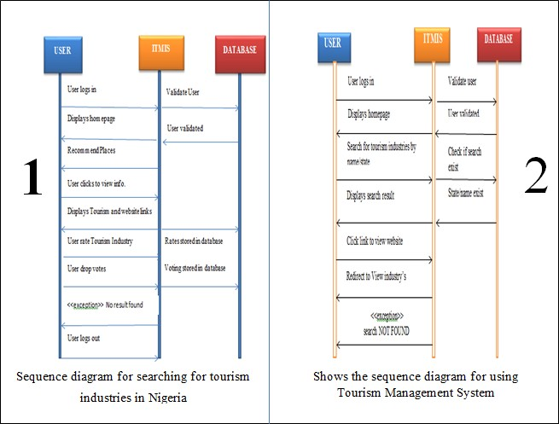

**Figure 2:** System Sequence diagram for TMS

# Screenshot

# Findings/Results

In the design of the TMS, information pertaining to tourist locations in Nigeria was not completely gathered thus reducing the functions TMS is intended to carry out but design maintains a centralized database of fifty

(50) tourist locations and all related information in Nigeria. In addition to managing tourism information, we were able to implement a recommendation filtering system that can improve science and autonomy of the system thus assisting tourist in decision making process. The designed system is user-friendly, interactive, and compatible to every web browsers running on any hardware and the interface was beautifully designed for attractiveness and to promote efficiency and productivity of the website.

# Limitations

The study was limited to fifty (50) tourist locations in Nigeria; spanning both the Natural and artificial attractions. There were cost and time implications during the course of the study as it required gathering information of tourist locations over a large geographical area.

# Future Research

It is worth mentioning that this research work is open for further enhancement, with the expectation that it becomes more robust and better enhanced; covering every single tourist site in Nigeria. In addition, certain constraints, such as inadequate information sources for each of the tourist locations in Nigeria, some features were not included which would have made TMS a more robust management system.

Some of these features include the following;

1. In this study, only 50 tourist locations in Nigeria were used. Therefore, an improved system should incorporate every tourist site in Nigeria for better insight on available tourist attractions.
2. Provision of advertisement platform so that tourists will be able to get latest information on all the tourist locations in Nigeria
3. A fully functional reservation platform so that booking could be made via credit cards.
4. Provision of content scheduler to eliminate outdated information.

# Conclusion

In conclusion, this software will solve many problems in Nigeria relating to management of product and information pertaining to tourism. Tourists will get acquainted with all the tourist sites in Nigeria and information pertaining to those sites without physically extracting information from people or having to travel long distances to see what the location has to offer. With the availability of the Internet, users have access to TMS application; hence they are empowered with current and relevant information pertaining to tourism in Nigeria. The application will go a long way in assisting tourists in decision making, and also as a source of revenue to the country. TMS will make tourism round the country fun and easy because of easy access to relevant information.

# 9.Coding

# 